Do Now: At the back of the room are all the Supplies needed to solve the objective for the first part of this lesson. Each group is to get a lime wedge, Juice glass, petri dish, box of matches, and 10 ml of cranberry juice.
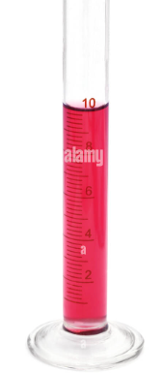
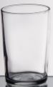
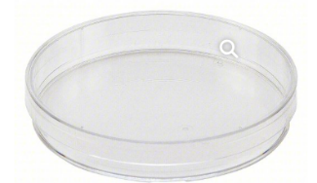
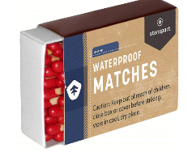
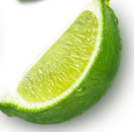

Students objective #1. Students objective is to get the cranberry juice into the juice glass without touching the petri dish after the cranberry juice is transferred to the petri dish. Students should draw there demonstration or they can use the diagrams above to cut and paste their setup in the box after they complete the objective.
Demonstration two:

Demonstration one.

Objective #2. How does one get the cranberry juice out of the juice glass? All students should then be able to draw that setup as well….. ( the only way to get the juice out of the glass is to ice massage it make it cold to release the pressure)
Arrows to show movement in both demonstrations would also be a great idea so that the student understands the mechanism. After a brief discussion about the demonstrations and the problem solving techniques.
Lets label the demonstration as either High pressure or low pressure. On the students worksheet I would keep all this blank so that it is more captivating and discovery mode. Next I would make each student write out what happened and main components that created each environment .
Demonstration #1

Demonstration #2

I believe here I would recreate a high pressure system like a person making a fist and condensing and squeezing making it as dense as ever and a low pressure system when your hands wants to expand and move away from that fist.

Questions:
#1. What type of pressure existed at demonstration one and explain with temperature and density?

#2. What type of pressure system existed at demonstrion two and with temperature and density?

#3. Project which pressure system would create a cloudy day and expalain.

#4, What allowed the juice to climb into the juice glass?

#5. Using the word expansion and condensation explain how movements of the air molecules moved the liquid into and out of the juice glass.

Closure:
At this point students should be able to see the correlation that hot air represents low pressure systems and cold air tends to create high pressure systems. So this might be a good time to take out the new ESRT on Page 19 and discuss the difference between high pressure belts and low pressure belts on Earth and how they create a certain climate based on the heating of the earth. Curved Surface vs Flat Plane
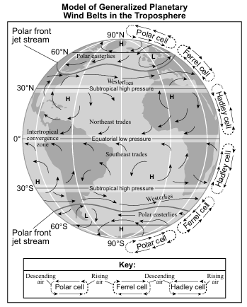

From here we could go into why low pressure creates a tropical zone and the type of weather associated with this particular area and how high pressure creastes a temperate zone? Types of fruits that are grown in these zones and the types of ecological succession that these zones have in common and the differences.

Also on Page 19 they show how high pressure and low pressute interact in a convection current in the troposphere. ( This might be a great time to explain how precipitation is created in a low pressure system in maybe a sequence/consequence follow up lesson.

